
Module 6.

Financial Mechanisms for Climate Change Adaptation

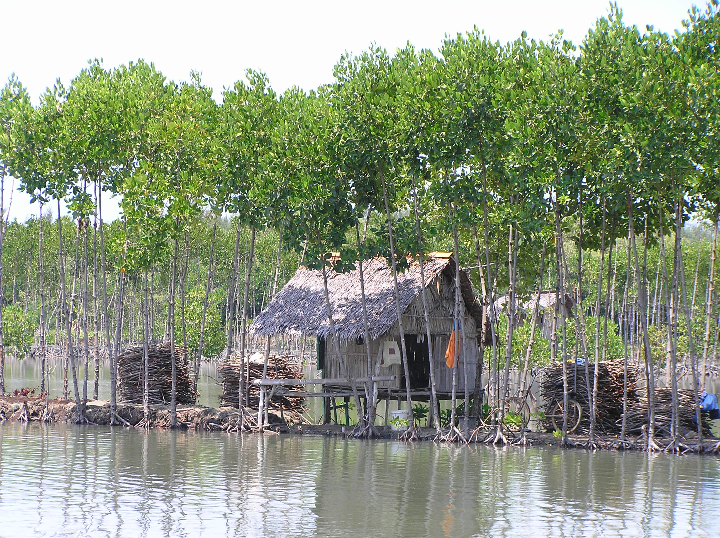

Lead

Pieter van Eijk, Wetlands International

With inputs from Catharien Terwisscha van Scheltinga, Wageningen University
Module 6. Financial Mechanisms for Climate Change Adaptation

Introduction
This module explains how financial mechanisms can be used for funding climate change adaptation activities that involve communities and incorporate ecosystem considerations. It explores the realm of bi- and multi-lateral adaptation funds that are currently under development and identifies innovative means of generating additional resources for adaptation. The second part of the module focuses on financial mechanisms that can be used to ensure that resources are effectively channeled to the ground level, so that community- and ecosystem-based approaches are effectively incorporated in adaptation planning.

Three of such practical mechanisms are being explored. First of all, the Bio-rights approach as an innovative means to integrate community- and ecosystem-based adaptation. Secondly, micro-insurance mechanisms that help to buffer the impacts of extreme events on the most vulnerable communities. And thirdly, community-based savings schemes which enable people to diversify their income and survive times of scarcity resulting from increasing climate variability.

Thus, the module touches upon both access and delivery of financial resources for adaptation and sketches the rapid yet uncertain developments in the field of adaptation finance.

Objectives.
- Participants know options to access, generate and distribute financial resources for community- and ecosystem-based climate change adaptation, and are able to translate this in their own setting into action

Specific objectives

- All participants know existing and emerging sources of adaptation funding relevant for their own work on climate change adaptation.

- All participants know options to generate new financial resources for climate change adaptation.

- All participants know three financial mechanisms that could support on the ground adaptation action.

Content.

Financial Mechanisms for Climate Change Adaptation
In recent years, the need for the development of appropriate mechanisms for funding climate change adaptation has become increasingly recognised. This is a direct result of the materialization of over 40 National Adaptation Programmes of Action (NAPAs) which all require short term funding and appropriate mechanisms for the distribution of resources. Recent estimates of the annual costs of adaptation – some of which have come up with figures in extent of 100 billion USD – have also contributed to the fact that ‘adaptation finance’ is currently based at the forefront of the policy dialogue around adaptation.
In this context, two aspects are of critical importance; The allocation of resources for climate change adaptation and the design of mechanisms that channel resources to the ground level, so that community- and ecosystem-based approaches are effectively incorporated in adaptation planning.

Accessing funding for adaptation
Various funds that are specifically oriented at funding climate change adaptation have emerged recently, under the authority of World bank, the GEF and various other bi- and multi-lateral bodies. Most of these have been set up as pilots, to explore the appropriateness of different funding structures and to pilot small-scale adaptation measures on the ground. These funds will form the basis for the design of a new generation of larger-scale and more efficient, effective and equitable funding structures in the years to come. The Adaptation fund which has been established under UNFCCC currently evolves as a promising new mechanism for adaptation funding, although it is not expected to become fully operational until beyond 2012.
While existing funds for adaptation are currently unable to cover all the costs for adaptation, traditional sources of development funding could help to fulfill many short-term needs. Most donors for example, have allocated funding windows that allow for climate proofing of their respective conservation and development programmes. Alternatively, mechanisms that have proven their effectiveness in generating resources for sustainable development and conservation, such as Payments for Environmental Services (PES) or taxing of polluting practices can be tailored towards specific adaptation needs.

Financial mechanisms for grassroots level adaptation
In addition to mechanisms that generate resources and which administer funds at a regional or national levels, it is instrumental to also put in place tools for the dissemination and management of funds at the ground level. The conservation and development sector has gained a wealth of experiences with countless financial mechanisms that could prove of great value for adaptation. The three approaches that are described below serve as examples of such mechanism. They could be implemented as adaptation tools on their own, or alternatively could be linked to other mechanisms in which single elements merge into new funding structures.
Bio-rights is an innovative financial mechanism that links sustainable livelihoods development and environmental conservation. By providing micro-credits for development activities, rural communities are incentivized to actively engage in the conservation and restoration of their natural environment. The micro-credits are converted into definitive payments upon successful delivery of conservation services towards the end of a contracting period. The approach covers the opportunity costs of adopting a more sustainable development strategy, while sustaining important ecosystem services such as provisioning of fisheries resources, flood regulation and storm mitigation. As such the so-called poverty trap, a mutually reinforcing process of poverty leading to environmental degradation and – vice versa – the degradation leading to increased poverty and vulnerability is addressed. This does directly benefit both the communities themselves as well as stakeholders elsewhere.

These features are of great relevance from an adaptation perspective; First of all the micro-credits could be used to adopt adequate household level adaptation measures. Communities can use them for example to invest in climate proofing of their housing, diversification of their livelihood activities or to adapt existing income generating practices. The conservation measures that are implemented can help to increase landscape level resilience to climate change. Planting of mangroves for example buffers the impacts of storms and saltwater intrusion, while peatland restoration can help to reinstall the capacity of these systems to regulate floods and droughts. As ecosystems provide services across wider geographical areas, these measures increase the resilience of people living both in- and outside of the target areas. The approach can also contribute to ensuring financial security. Communities can use group savings to establish revolving funds which act as buffers to overcome the impact of climate hazards such as droughts, floods and storms. Likewise they can invest in food banks or emergency supplies.

Micro-insurance, like traditional insurance, is a risk-sharing mechanism in which premiums are paid by all members of the insurance scheme. This pool of premiums is used to reimburse those members of the scheme who suffer losses from a pre-defined set of perils. The difference between micro-insurance and traditional insurance, however, is that micro-insurance specifically sets out to provide affordable and accessible insurance to low-income people who cannot gain access to traditional forms of insurance. As such, the “goal of micro-insurance” is to make appropriate, affordable risk-management tools available to the poor to help support their economic development by providing a precautionary (ex ante) mechanism for coping with losses.

As a risk-transferring mechanism, micro-insurance is a welcome addition to existing coping strategies within communities in that it can helps to overcome large losses, even if they are covariate and affect all members of the community at the same time. Micro-insurance schemes are varied, but can be divided into two broad categories; conventional or indemnity micro-insurance schemes, and index-based schemes. Conventional micro-insurance, works in the same way as traditional insurance, with a premium paid to the insurer to protect against the actual losses from a certain set of perils, and claims then filed if losses occur due to those pre-defined perils. Index based insurance works in a fundamentally different way in that payments are linked to an ‘index’ of a given hazard and a known correlation between this hazard and associated losses. By administering pay-outs based on the index (e.g. rainfall, temparature or wind velocity), the high costs of validating actual damages in the field are avoided. A main disadvantage of index-based insurance is that the establishment of correlations can be difficult, costly and sometimes impossible due to lack of long-term data.
Community-based savings schemes are a form of micro-finance in which community groups establish their own fund in which they regularly save a small amount of money.
The funds allow group members to borrow small amounts of funding from their respective funds on a rotational basis. A small interest rate is paid upon reimbursement. Pilots have demonstrated that, with appropriate support, stable and rapidly growing funds can be established that can operate on their own, even in instable environments. These saving schemes offer an attractive alternative to traditional micro-finance in that they could help to cover the financial needs of vulnerable rural communities which micro-finance institutions would be hesitant to work with due to ‘defaulting’ risks or as a result of high transaction costs.
Strengthening financial security among rural communities is seen as a key strategy for overcoming shocks that result from climate change and to accrue capital within communities for costly adaptation measures, such as infrastructure development or procurement of seeds and farming equipment. Community-based savings schemes therefore, offer an attractive funding mechanism for adaptation, by helping vulnerable people to overcome both the impact of unexpected hazards and by strengthening the funding base in support of more gradual long term adaption actions

Method.

Powerpoint presentation with discussion and questions.
Session plan module 6. Financial mechanisms for climate change adaptation
Time | Content | Learning Objectives | Methods | Materials | Actions | Responsible person
09.15-09.20 | Introduction to module 6 | Participants know the learning objectives and module programme | Short Power point presentation | Powerpoint Presentation 6.1 slide 1 to 4  beamer | Prepare introduction
09.20-10.20 | Lecture 1. “Financial mechanisms for grassroots level adaptation”. | Participants know three financial mechanisms that support on the ground adaptation action. | Powerpoint presentation 6.1  questions | Powerpoint presentation 6.1 “Financial mechanisms for grassroots level adaptation”  beamer | Prepare Powerpoint lecture
10.20-10.40 | Break |  |  |  | Prepare flipchart with grid
10.40-11.15 |  |  | Plenary reflection  Exercise sheet 6.1 | Flipchart with grid | Prepare flipchart with grid
11.15-12.15 | Lecture 2. “Accessing funding for climate change adaptation | Participants know existing and emerging sources of adaptation funding relevant for their own work on climate change adaptation.  Participants know options to generate new financial resources for climate change adaptation. | Powerpoint presentation 6.2  questions  Ask participants to name any other useful source of funding they are aware of. Ask participants experiences with funding sources. Note of flipchart for the benefit of all. | Powerpoint presentation 6.2  “Assessing funding for climate change adaptation”  Empty flipchart | Prepare powerpoint lecture
12.15-12.30 | Summary and wrap up | Participants know the major findings of the session and key messages
12.30-13.30 | Lunch

Exercise 6.1 Designing a financial mechanism for climate change adaptation
Aim:
Participants know the pro’s and con’s of three financial mechanisms that support on the ground adaptation action.

Method:
1. After the Powerpoint presentation, the moderator puts a flipchart with a grid on the wall

Issue | Bio-rights | Community-based savings schemes | Micro-insurance
Strong points of concept
Weak points of concept
Is it accessible to all target groups?
-Men
-Women
-Landowners
-Tenants
-Landless
Which government/private institutes have to be engaged?

2. Participants reflect in plenary on the issues one by one. Avoid long debates; it is a “quick and dirty” exercise”

3. Wrap up by stating the following comments:
- The success and adaptability of the 3 methods depends very much on the local situation.
- Mind that the community is not a level playing field. Be aware of whom is excluded and who is included. Mind that usually the resourceful people have a better change to grap the opportunity (see also the module on community bases adaptation and perhaps the field visit)
- Rate of success of the methods depends on the economic opportunities in the area for income generation. So economic assessments are part of the pre-studies and discussions with the communities
- Rate of success of the method depends on the capacity and cooperation of the engaging partner institutes and possible private enterprises/banks/traders etc.

Timing:
Plenary input: 15 minutes
Warp up: 5 minutes

Materials: Flip chart with grid

Alternatives:
-Same exercise, but in subgroups. Will take 1 hr.
-alternative exercise 6.2 that zooms in on the applicability of the methods in the work situation of the participants

Alternative Exercise 6.2 Designing a financial mechanism for climate change adaptation
Aim:
At the end of the session participants:
- Have designed their own financial mechanisms for adaptation, based upon their existing experiences and on the approaches that were introduced in lecture 1.
- Have discussed the applicability of (elements of) financial mechanisms within their own context.

Method:

- Organise groups of 5-7 people, and ask each group to appoint a reporter. Where possible ensure that people that come from the same area/country are clustered together.
- Ask each group to have a short brainstorm (maximum 15 minutes) to define a local ‘climate context’ based upon their own experiences; i.e. ask them to identify and describe a case in which specific climate impacts, vulnerabilities etc. provide a threat to the environment and to human development. Participants can develop such a case, based upon experiences from their home countries. Alternatively, a project site visited during the training could serve as a case study area. In that case, participants would undertake this exercise based upon their observations during the field trip.
- Ask participants to invent an innovative financial mechanism that can help to solve the identified ‘climate change problem’. Stimulate them to do so by linking elements of the financial mechanisms that were presented in lecture 1 together and invite people to integrate their own context specific knowledge and experiences. Instruct people to design their mechanisms such that it addresses the selected climate change problems in a holistic way, e.g. by linking conservation and development approaches.
- Ask participants to describe their selected case and the related financial mechanism on a flipchart.
- Invite each rapporteur to present group findings during a 5 minute presentation. Allow for a short questions and answers session after each presentation
- Facilitate a plenary discussion, to identify the strengths and weaknesses in the proposed mechanisms and explore how the success of different approaches depends on a given local context.
- Wrap-up by summarizing key findings of the session.

Timing:
Introduction to the assignment: 5 minutes
Break-out group work: 55 minutes
Plenary presentations of group work: 30 minutes
Plenary discussion: 30 minutes

Materials: Flip charts, tape, a large room, markers

Alternatives:
A shorter plenary discussion (30 minutes), in which the moderator allows for group reflections on the mechanisms presented in lecture 1 could serve as an alternative to this assignment in case of time constraints.

