Description of partners

Wetlands International
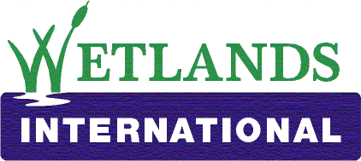

Wetlands International is a global organization that works to sustain and restore wetlands and their resources for people and biodiversity. It’s an independent, not-for- profit, global organization active in over 100 countries and at several, very different scales to tackle the most pressing problems affecting wetlands through its 20 regional, national or project offices, coordinated by the head office in Ede, the Netherlands. Its work ranges from research and community-based field projects to advocacy and engagement with governments, corporate and international policy fora and conventions. Wetlands International works through partnerships and is supported by government and NGO membership from around the world and relies on an extensive specialist expert network and tens of thousands of volunteers. Wetlands International is the leading scientific expert on wetlands & water bird migration as well as peatlands & climate change and coordinates the International Water bird Census, which provides the basic data for the assessment of the global state of water birds and for analysis of changes in their population. www.wetlands.org

Conservation International
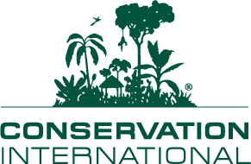

Conservation International is a global organization, committed to helping societies adopt a more sustainable approach to development – one that considers and values nature at every turn. For more than twenty years Conservation International has empowered communities in both jungles and deserts to make conservation part of their livelihoods. CI has partnerships with business such as Starbucks and Wal-Mart, aiming to make conservation part of their business model. Governments from Costa Rica to China have worked with us to make conservation a core component of their national policies. Throughout this process, every strategy, every action has been guided by ground-breaking science. www.conservation.org

World Wide Fund

For more than 45 years, WWF has been protecting the future of nature. The world’s leading conservation organization, WWF works in 100 countries and is supported by 1.2 million members in the United States and close to 5 million globally. WWF's unique way of working combines global reach with a foundation in science, involves action at every level from local to global, and ensures the delivery of innovative solutions that meet the needs of both people and nature. WWF is committed to reversing the degradation of the planet's natural environment and to building a future in which human needs are met in harmony with nature. WWF recognizes the critical relevance of human numbers, poverty and consumption patterns to meeting these goals. www.worldwildlife.org

Co-operative Programme on Water and Climate
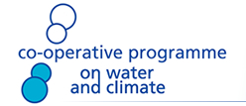

The Co-operative Programme on Water and Climate (CPWC) aims to stimulate activities in the water sector that contribute to managing the effects of climate variability and change, in particular for the most vulnerable communities. The CPWC builds bridges between water managers and the climate community, from the local up to the global level. Through increasing awareness of the issues and of potential solutions CPWC seeks to set in motion social and political processes that will lead to the adoption of coping strategies and best practices. www.waterandclimate.org

Email addresses of course developers and main contributors:

Charlotte.Floors@wetlands.org

Dieuwke.Klaver@wur.nl

eliot.levine@wwfus.org

h.vanschaik@cpwc.nl

john.matthews@wwfus.org

Liesbeth.vanbrink@wetlands.org

Nicolas.Tubbs@wetlands.org

Pieter.vanEijk@wetlands.org

t.hills@conservation.org

Tunde.Ojei@wetlands.org

